In this document we will discuss how the execution for this project went in Data group and what

methods were used to meet the deadline.

For this project we used Scrum as we did last semester. It was perfect for us since we have

experience using it and it hasn’t failed us. Since we defined all of the task relevant to this

project we were able to divide them into sprints with each sprint being one week long.

While using the Unified process methodology we followed the 4 steps, inception, elaboration,

construction and testing. While we separated the work between us everyone was still

knowing what the other people were doing to understand the code as best as

possible. In the inception face, we discussed and developed user stories that were made for this

project managed all the requirements and scenarios. In the elaboration face we spent time

creating all our relevant diagrams such as Activity, class, sequence and use case diagrams.

All of this helped us visualize the concept and gives us a better understanding of how the

system should respond and act.

In the construction face, we started coding our system on the base we created in the

elaboration face. Taking into account all of the previously made diagrams for understanding

the needed methods.

In the testing face, we tested our application in such detail as we deemed necessary. Just to

see if everything works as intended and if any exceptions happened correct them.

There where, at points, moments where we hit a wall and didn’t know how to fix a problem

and had to seek help from the supervisors. Other times we just debated the topic and

discussed it between our own.

As for assistance materials, we used mostly online materials, tutorials and instructive videos

all of which helped us reach the desired end-point of our project. Since this semester we had

to work with different things, we had to look for information and seek assistance from our supervisors.

In Addition, we created a burndown chart in Figure 1. to show us our progress during the

weeks worked on the project.

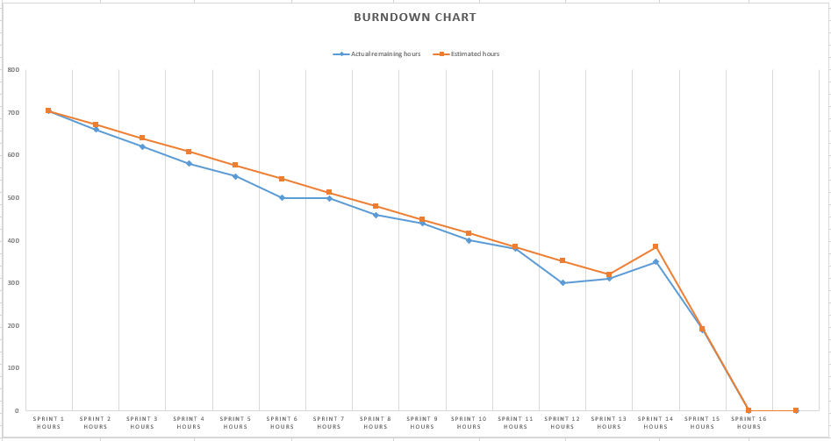

A close up of a map

Description generated with very high confidenceCantt Chart

A close up of a map

Description generated with high confidence

A screenshot of a computer

Description generated with very high confidence

A picture containing map, indoor, computer

Description generated with high confidence

A screenshot of a cell phone

Description generated with high confidence

Scrum:

During the development of the system an agile framework has been used which is SCRUM.

Roles were assigned to our group members so that each one of us will know what his task

during the Scrum is and how he should prepare for the next meeting.

Our roles were:

Product owner:

The whole group members were presenting the product owner of our system. The purpose was

to create a vision of what he wishes to build and convey that vision to the scrum team.

Scrum master: Fadi Dasus

Fadi was the Scrum master in our group. His purpose was to maintain a good and calm

environment. Also, he was the one who planned out the Scrum meetings. During the meetings

he was the one to set up who is responsible for certain tasks. There were some obstacles that

our team encountered but not for a long time because Fadi was trying hard to find a solution

for the problem.

Development team: Balkis Ibrahim, Fadi, Yasin and Nadeem

They work on creating and improving the system. The main goal of the development team

was to implement the tasks which can be found in the sprints also to deliver the requested

and committed product increments. During this project, our development team worked hard

in order to achieve the set-up goals.